**BC190202047_FAHAD**

**Final Year Project-Phase-3**

**Following are the output of the required results:**

* **Output of Barplot using ggplot2 library according to the ratings:**

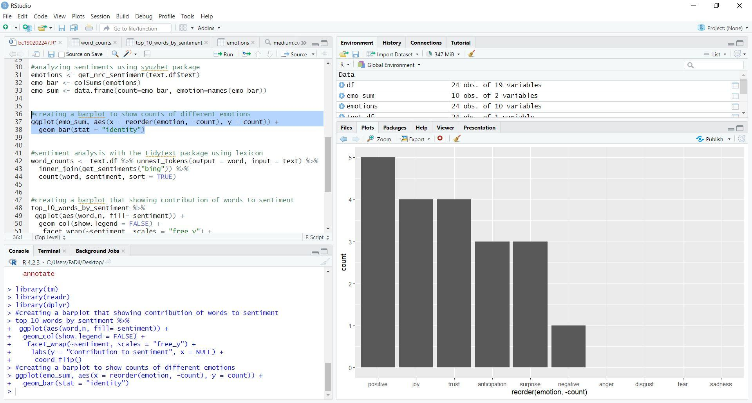

* **Output of WordClouds on comments using wordclouds2 library:**

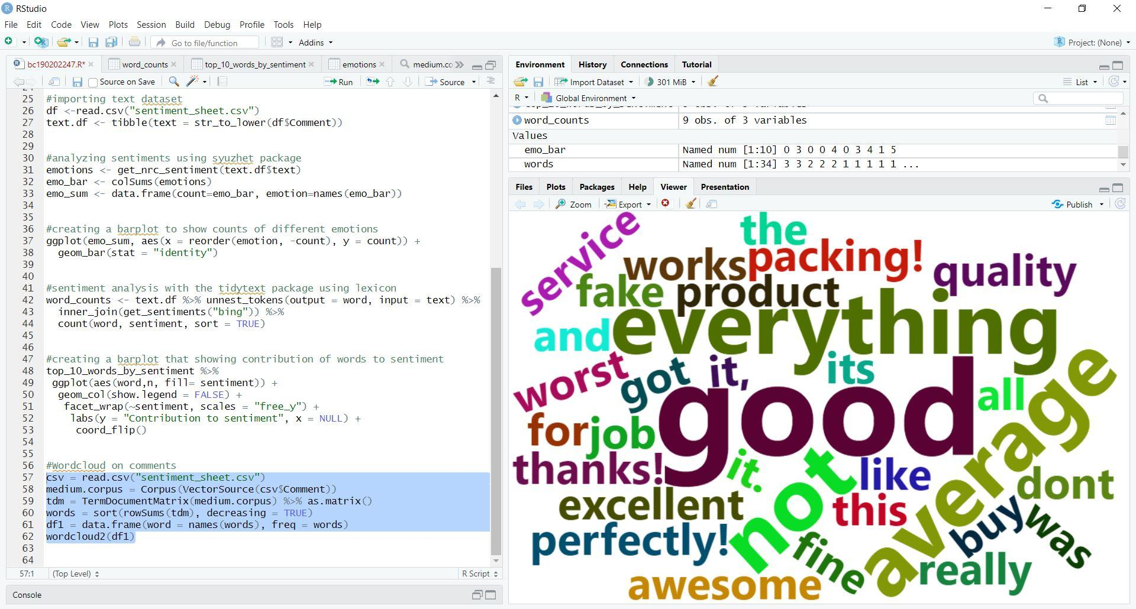

* **Sentiments according to the comments using get_nrc_sentiment function:**

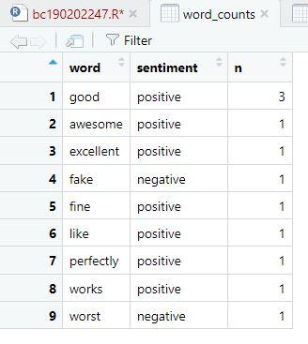

* **Barplot according to the sentiments:**

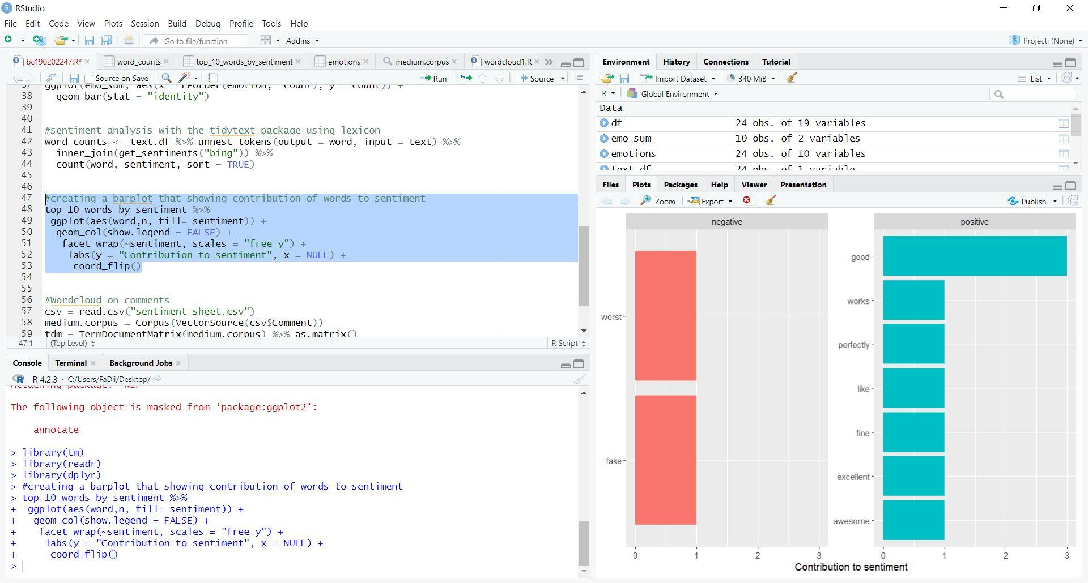

**Solution 2:**

1. **Name: Fahad**

|  |  |  |  |  |  |  |
| --- | --- | --- | --- | --- | --- | --- |
| **Sr. No** | **Comments** | **Sentiment by tool** | **Sentiment by people** | **Sentiment score by tool** | **Sentiment score by people** | **Accuracy in %** |
| **1** | Bad resolution | Negative | Negative | -6 | -6 | 100 |
| **2** | Thanks for the good service and feedback | Positive | Positive | 7 | 9 | 90 |
| **3** | Not really good | Negative | Negative | -2 | -2 | 100 |
| **4** | Display is awesome | Positive | Positive | 6 | 6 | 100 |
| **5** | Awful Experience | Negative | Negative | -5 | -5 | 100 |
| **6** | Product is working perfectly | Positive | Positive | 6 | 8 | 90 |
| **7** | An average experience | Neutral | Neutral | 0 | 0 | 100 |
| **8** | I Like this product | Positive | Positive | 3 | 3 | 100 |
| **9** | Got it. Excellent job of packing! Everything works perfectly! Thanks! | Positive | Positive | 9 | 9 | 100 |
| **10** | Working fine | Positive | Positive | 2 | 2 | 100 |
| **11** | don’t buy it, its fake | Negative | Negative | -5 | -5 | 100 |
| **12** | not good at all | Negative | Negative | -2 | -5 | 85 |
| **13** | Fine quality | Positive | Positive | 2 | 2 | 100 |
| **14** | my experience was just average | Neutral | Neutral | 0 | 0 | 100 |
| **15** | Superb experience. Job done very well | Positive | Positive | 7 | 7 | 100 |
| **16** | Everything was awesome | Positive | Positive | 6 | 6 | 100 |
| **17** | This product is really good | Positive | Positive | 4 | 4 | 100 |
| **18** | really bad experience | Negative | Negative | -6 | -6 | 100 |
| **19** | print quality is not good | Negative | Negative | -2 | -4 | 90 |
| **20** | Display quality is superb | Positive | Positive | 6 | 6 | 100 |
| **21** | Fake product | Negative | Negative | -5 | -5 | 100 |
| **22** | The result of camera is awesome | Positive | Positive | 6 | 6 | 100 |
| **23** | lens is not of good quality | Negative | Negative | -2 | -5 | 85 |
| **24** | Really bad product, vibration sensor does not work | Negative | Negative | -6 | -6 | 100 |
| **25** | waste of money because it is not heating at all | Negative | Negative | -5 | -8 | 85 |
| **26** | I really like the build quality and display quality | Positive | Positive | 4 | 4 | 100 |
| **27** | Build quality is average | Neutral | Neutral | 0 | 0 | 100 |
| **28** | Good resolution | Positive | Positive | 4 | 4 | 100 |
| **29** | Projection light is nice | Positive | Positive | 5 | 5 | 100 |
| **30** | Really awesome product according to my needs | Positive | Positive | 6 | 6 | 100 |

1. **Name: Touseef**

|  |  |  |  |  |  |  |
| --- | --- | --- | --- | --- | --- | --- |
| **Sr. No** | **Comments** | **Sentiment by tool** | **Sentiment by people** | **Sentiment score by tool** | **Sentiment score by people** | **Accuracy in %** |
| **1** | Bad resolution | Negative | Negative | -6 | -6 | 100 |
| **2** | Thanks for the good service and feedback | Positive | Positive | 7 | 7 | 100 |
| **3** | Not really good | Negative | Negative | -2 | -2 | 100 |
| **4** | Display is awesome | Positive | Positive | 6 | 6 | 100 |
| **5** | Awful Experience | Negative | Negative | -5 | -8 | 85 |
| **6** | Product is working perfectly | Positive | Positive | 6 | 6 | 100 |
| **7** | An average experience | Neutral | Neutral | 0 | 0 | 100 |
| **8** | I Like this product | Positive | Positive | 3 | 3 | 100 |
| **9** | Got it. Excellent job of packing! Everything works perfectly! Thanks! | Positive | Positive | 9 | 9 | 100 |
| **10** | Working fine | Positive | Positive | 2 | 2 | 100 |
| **11** | don’t buy it, its fake | Negative | Negative | -5 | -9 | 80 |
| **12** | not good at all | Negative | Negative | -2 | -5 | 85 |
| **13** | Fine quality | Positive | Positive | 2 | 2 | 100 |
| **14** | my experience was just average | Neutral | Neutral | 0 | 0 | 100 |
| **15** | Superb experience. Job done very well | Positive | Positive | 7 | 7 | 100 |
| **16** | Everything was awesome | Positive | Positive | 6 | 9 | 85 |
| **17** | This product is really good | Positive | Positive | 4 | 4 | 100 |
| **18** | really bad experience | Negative | Negative | -6 | -6 | 100 |
| **19** | print quality is not good | Negative | Negative | -2 | -2 | 100 |
| **20** | Display quality is superb | Positive | Positive | 6 | 6 | 100 |
| **21** | Fake product | Negative | Negative | -5 | -7 | 90 |
| **22** | The result of camera is awesome | Positive | Positive | 6 | 6 | 100 |
| **23** | lens is not of good quality | Negative | Negative | -2 | -2 | 100 |
| **24** | Really bad product, vibration sensor does not work | Negative | Negative | -6 | -6 | 100 |
| **25** | waste of money because it is not heating at all | Negative | Negative | -5 | -8 | 85 |
| **26** | I really like the build quality and display quality | Positive | Positive | 4 | 4 | 100 |
| **27** | Build quality is average | Neutral | Neutral | 0 | 0 | 100 |
| **28** | Good resolution | Positive | Positive | 4 | 4 | 100 |
| **29** | Projection light is nice | Positive | Positive | 5 | 5 | 100 |
| **30** | Really awesome product according to my needs | Positive | Positive | 6 | 6 | 100 |

1. **Name: Ashar**

|  |  |  |  |  |  |  |
| --- | --- | --- | --- | --- | --- | --- |
| **Sr. No** | **Comments** | **Sentiment by tool** | **Sentiment by people** | **Sentiment score by tool** | **Sentiment score by people** | **Accuracy in %** |
| **1** | Bad resolution | Negative | Negative | -6 | -6 | 100 |
| **2** | Thanks for the good service and feedback | Positive | Positive | 7 | 7 | 100 |
| **3** | Not really good | Negative | Negative | -2 | -5 | 85 |
| **4** | Display is awesome | Positive | Positive | 6 | 6 | 100 |
| **5** | Awful Experience | Negative | Negative | -5 | -9 | 80 |
| **6** | Product is working perfectly | Positive | Positive | 6 | 6 | 100 |
| **7** | An average experience | Neutral | Neutral | 0 | 0 | 100 |
| **8** | I Like this product | Positive | Positive | 3 | 3 | 100 |
| **9** | Got it. Excellent job of packing! Everything works perfectly! Thanks! | Positive | Positive | 9 | 9 | 100 |
| **10** | Working fine | Positive | Positive | 2 | 2 | 100 |
| **11** | don’t buy it, its fake | Negative | Negative | -5 | -10 | 75 |
| **12** | not good at all | Negative | Negative | -2 | -8 | 70 |
| **13** | Fine quality | Positive | Positive | 2 | 3 | 95 |
| **14** | my experience was just average | Neutral | Neutral | 0 | 0 | 100 |
| **15** | Superb experience. Job done very well | Positive | Positive | 7 | 7 | 100 |
| **16** | Everything was awesome | Positive | Positive | 6 | 10 | 80 |
| **17** | This product is really good | Positive | Positive | 4 | 5 | 95 |
| **18** | really bad experience | Negative | Negative | -6 | -6 | 100 |
| **19** | print quality is not good | Negative | Negative | -2 | -2 | 100 |
| **20** | Display quality is superb | Positive | Positive | 6 | 6 | 100 |
| **21** | Fake product | Negative | Negative | -5 | -10 | 75 |
| **22** | The result of camera is awesome | Positive | Positive | 6 | 6 | 100 |
| **23** | lens is not of good quality | Negative | Negative | -2 | -2 | 100 |
| **24** | Really bad product, vibration sensor does not work | Negative | Negative | -6 | -8 | 90 |
| **25** | waste of money because it is not heating at all | Negative | Negative | -5 | -10 | 75 |
| **26** | I really like the build quality and display quality | Positive | Positive | 4 | 7 | 85 |
| **27** | Build quality is average | Neutral | Neutral | 0 | 0 | 100 |
| **28** | Good resolution | Positive | Positive | 4 | 4 | 100 |
| **29** | Projection light is nice | Positive | Positive | 5 | 5 | 100 |
| **30** | Really awesome product according to my needs | Positive | Positive | 6 | 6 | 100 |

1. **Name: Suheer**

|  |  |  |  |  |  |  |
| --- | --- | --- | --- | --- | --- | --- |
| **Sr. No** | **Comments** | **Sentiment by tool** | **Sentiment by people** | **Sentiment score by tool** | **Sentiment score by people** | **Accuracy in %** |
| **1** | Bad resolution | Negative | Negative | -6 | -3 | 85 |
| **2** | Thanks for the good service and feedback | Positive | Positive | 7 | 7 | 100 |
| **3** | Not really good | Negative | Negative | -2 | -2 | 100 |
| **4** | Display is awesome | Positive | Positive | 6 | 5 | 95 |
| **5** | Awful Experience | Negative | Negative | -5 | -5 | 100 |
| **6** | Product is working perfectly | Positive | Positive | 6 | 10 | 80 |
| **7** | An average experience | Neutral | Neutral | 0 | 0 | 100 |
| **8** | I Like this product | Positive | Positive | 3 | 3 | 100 |
| **9** | Got it. Excellent job of packing! Everything works perfectly! Thanks! | Positive | Positive | 9 | 9 | 100 |
| **10** | Working fine | Positive | Positive | 2 | 2 | 100 |
| **11** | don’t buy it, its fake | Negative | Negative | -5 | -10 | 75 |
| **12** | not good at all | Negative | Negative | -2 | -9 | 65 |
| **13** | Fine quality | Positive | Positive | 2 | 3 | 95 |
| **14** | my experience was just average | Neutral | Neutral | 0 | 0 | 100 |
| **15** | Superb experience. Job done very well | Positive | Positive | 7 | 7 | 100 |
| **16** | Everything was awesome | Positive | Positive | 6 | 10 | 80 |
| **17** | This product is really good | Positive | Positive | 4 | 5 | 95 |
| **18** | really bad experience | Negative | Negative | -6 | -6 | 100 |
| **19** | print quality is not good | Negative | Negative | -2 | -2 | 100 |
| **20** | Display quality is superb | Positive | Positive | 6 | 6 | 100 |
| **21** | Fake product | Negative | Negative | -5 | -10 | 75 |
| **22** | The result of camera is awesome | Positive | Positive | 6 | 6 | 100 |
| **23** | lens is not of good quality | Negative | Negative | -2 | -2 | 100 |
| **24** | Really bad product, vibration sensor does not work | Negative | Negative | -6 | -6 | 100 |
| **25** | waste of money because it is not heating at all | Negative | Negative | -5 | -9 | 80 |
| **26** | I really like the build quality and display quality | Positive | Positive | 4 | 7 | 85 |
| **27** | Build quality is average | Neutral | Neutral | 0 | 0 | 100 |
| **28** | Good resolution | Positive | Positive | 4 | 4 | 100 |
| **29** | Projection light is nice | Positive | Positive | 5 | 5 | 100 |
| **30** | Really awesome product according to my needs | Positive | Positive | 6 | 6 | 100 |

1. **Name: Usama**

|  |  |  |  |  |  |  |
| --- | --- | --- | --- | --- | --- | --- |
| **Sr. No** | **Comments** | **Sentiment by tool** | **Sentiment by people** | **Sentiment score by tool** | **Sentiment score by people** | **Accuracy in %** |
| **1** | Bad resolution | Negative | Negative | -6 | -8 | 90 |
| **2** | Thanks for the good service and feedback | Positive | Positive | 7 | 8 | 95 |
| **3** | Not really good | Negative | Negative | -2 | -2 | 100 |
| **4** | Display is awesome | Positive | Positive | 6 | 6 | 100 |
| **5** | Awful Experience | Negative | Negative | -5 | -5 | 100 |
| **6** | Product is working perfectly | Positive | Positive | 6 | 10 | 80 |
| **7** | An average experience | Neutral | Neutral | 0 | 0 | 100 |
| **8** | I Like this product | Positive | Positive | 3 | 5 | 90 |
| **9** | Got it. Excellent job of packing! Everything works perfectly! Thanks! | Positive | Positive | 9 | 10 | 95 |
| **10** | Working fine | Positive | Positive | 2 | 2 | 100 |
| **11** | don’t buy it, its fake | Negative | Negative | -5 | -10 | 75 |
| **12** | not good at all | Negative | Negative | -2 | -10 | 60 |
| **13** | Fine quality | Positive | Positive | 2 | 2 | 100 |
| **14** | my experience was just average | Neutral | Neutral | 0 | 0 | 100 |
| **15** | Superb experience. Job done very well | Positive | Positive | 7 | 9 | 90 |
| **16** | Everything was awesome | Positive | Positive | 6 | 10 | 80 |
| **17** | This product is really good | Positive | Positive | 4 | 5 | 95 |
| **18** | really bad experience | Negative | Negative | -6 | -6 | 100 |
| **19** | print quality is not good | Negative | Negative | -2 | -2 | 100 |
| **20** | Display quality is superb | Positive | Positive | 6 | 6 | 100 |
| **21** | Fake product | Negative | Negative | -5 | -10 | 75 |
| **22** | The result of camera is awesome | Positive | Positive | 6 | 6 | 100 |
| **23** | lens is not of good quality | Negative | Negative | -2 | -2 | 100 |
| **24** | Really bad product, vibration sensor does not work | Negative | Negative | -6 | -6 | 100 |
| **25** | waste of money because it is not heating at all | Negative | Negative | -5 | -10 | 75 |
| **26** | I really like the build quality and display quality | Positive | Positive | 4 | 8 | 80 |
| **27** | Build quality is average | Neutral | Neutral | 0 | 0 | 100 |
| **28** | Good resolution | Positive | Positive | 4 | 4 | 100 |
| **29** | Projection light is nice | Positive | Positive | 5 | 5 | 100 |
| **30** | Really awesome product according to my needs | Positive | Positive | 6 | 6 | 100 |

1. **Name: Hamza**

|  |  |  |  |  |  |  |
| --- | --- | --- | --- | --- | --- | --- |
| **Sr. No** | **Comments** | **Sentiment by tool** | **Sentiment by people** | **Sentiment score by tool** | **Sentiment score by people** | **Accuracy in %** |
| **1** | Bad resolution | Negative | Negative | -6 | -6 | 100 |
| **2** | Thanks for the good service and feedback | Positive | Positive | 7 | 7 | 100 |
| **3** | Not really good | Negative | Negative | -2 | -4 | 90 |
| **4** | Display is awesome | Positive | Positive | 6 | 6 | 100 |
| **5** | Awful Experience | Negative | Negative | -5 | -8 | 85 |
| **6** | Product is working perfectly | Positive | Positive | 6 | 10 | 80 |
| **7** | An average experience | Neutral | Neutral | 0 | 0 | 100 |
| **8** | I Like this product | Positive | Positive | 3 | 3 | 100 |
| **9** | Got it. Excellent job of packing! Everything works perfectly! Thanks! | Positive | Positive | 9 | 9 | 100 |
| **10** | Working fine | Positive | Positive | 2 | 2 | 100 |
| **11** | don’t buy it, its fake | Negative | Negative | -5 | -10 | 75 |
| **12** | not good at all | Negative | Negative | -2 | -8 | 70 |
| **13** | Fine quality | Positive | Positive | 2 | 4 | 90 |
| **14** | my experience was just average | Neutral | Neutral | 0 | 0 | 100 |
| **15** | Superb experience. Job done very well | Positive | Positive | 7 | 9 | 90 |
| **16** | Everything was awesome | Positive | Positive | 6 | 10 | 80 |
| **17** | This product is really good | Positive | Positive | 4 | 8 | 80 |
| **18** | really bad experience | Negative | Negative | -6 | -6 | 100 |
| **19** | print quality is not good | Negative | Negative | -2 | -5 | 85 |
| **20** | Display quality is superb | Positive | Positive | 6 | 6 | 100 |
| **21** | Fake product | Negative | Negative | -5 | -10 | 75 |
| **22** | The result of camera is awesome | Positive | Positive | 6 | 6 | 100 |
| **23** | lens is not of good quality | Negative | Negative | -2 | -2 | 100 |
| **24** | Really bad product, vibration sensor does not work | Negative | Negative | -6 | -6 | 100 |
| **25** | waste of money because it is not heating at all | Negative | Negative | -5 | -8 | 85 |
| **26** | I really like the build quality and display quality | Positive | Positive | 4 | 10 | 70 |
| **27** | Build quality is average | Neutral | Neutral | 0 | 0 | 100 |
| **28** | Good resolution | Positive | Positive | 4 | 4 | 100 |
| **29** | Projection light is nice | Positive | Positive | 5 | 5 | 100 |
| **30** | Really awesome product according to my needs | Positive | Positive | 6 | 9 | 85 |

1. **Name: Faiq**

|  |  |  |  |  |  |  |
| --- | --- | --- | --- | --- | --- | --- |
| **Sr. No** | **Comments** | **Sentiment by tool** | **Sentiment by people** | **Sentiment score by tool** | **Sentiment score by people** | **Accuracy in %** |
| **1** | Bad resolution | Negative | Negative | -6 | -6 | 100 |
| **2** | Thanks for the good service and feedback | Positive | Positive | 7 | 7 | 100 |
| **3** | Not really good | Negative | Negative | -2 | -7 | 75 |
| **4** | Display is awesome | Positive | Positive | 6 | 6 | 100 |
| **5** | Awful Experience | Negative | Negative | -5 | -9 | 80 |
| **6** | Product is working perfectly | Positive | Positive | 6 | 6 | 100 |
| **7** | An average experience | Neutral | Neutral | 0 | 0 | 100 |
| **8** | I Like this product | Positive | Positive | 3 | 5 | 90 |
| **9** | Got it. Excellent job of packing! Everything works perfectly! Thanks! | Positive | Positive | 9 | 9 | 100 |
| **10** | Working fine | Positive | Positive | 2 | 1 | 95 |
| **11** | don’t buy it, its fake | Negative | Negative | -5 | -10 | 75 |
| **12** | not good at all | Negative | Negative | -2 | -9 | 65 |
| **13** | Fine quality | Positive | Positive | 2 | 5 | 85 |
| **14** | my experience was just average | Neutral | Neutral | 0 | 0 | 100 |
| **15** | Superb experience. Job done very well | Positive | Positive | 7 | 10 | 85 |
| **16** | Everything was awesome | Positive | Positive | 6 | 10 | 80 |
| **17** | This product is really good | Positive | Positive | 4 | 6 | 90 |
| **18** | really bad experience | Negative | Negative | -6 | -6 | 100 |
| **19** | print quality is not good | Negative | Negative | -2 | -5 | 85 |
| **20** | Display quality is superb | Positive | Positive | 6 | 6 | 100 |
| **21** | Fake product | Negative | Negative | -5 | -10 | 75 |
| **22** | The result of camera is awesome | Positive | Positive | 6 | 6 | 100 |
| **23** | lens is not of good quality | Negative | Negative | -2 | -5 | 85 |
| **24** | Really bad product, vibration sensor does not work | Negative | Negative | -6 | -6 | 100 |
| **25** | waste of money because it is not heating at all | Negative | Negative | -5 | -10 | 75 |
| **26** | I really like the build quality and display quality | Positive | Positive | 4 | 8 | 80 |
| **27** | Build quality is average | Neutral | Neutral | 0 | 0 | 100 |
| **28** | Good resolution | Positive | Positive | 4 | 4 | 100 |
| **29** | Projection light is nice | Positive | Positive | 5 | 5 | 100 |
| **30** | Really awesome product according to my needs | Positive | Positive | 6 | 10 | 80 |

1. **Name: Umair**

|  |  |  |  |  |  |  |
| --- | --- | --- | --- | --- | --- | --- |
| **Sr. No** | **Comments** | **Sentiment by tool** | **Sentiment by people** | **Sentiment score by tool** | **Sentiment score by people** | **Accuracy in %** |
| **1** | Bad resolution | Negative | Negative | -6 | -6 | 100 |
| **2** | Thanks for the good service and feedback | Positive | Positive | 7 | 7 | 100 |
| **3** | Not really good | Negative | Negative | -2 | -2 | 100 |
| **4** | Display is awesome | Positive | Positive | 6 | 6 | 100 |
| **5** | Awful Experience | Negative | Negative | -5 | -8 | 85 |
| **6** | Product is working perfectly | Positive | Positive | 6 | 9 | 85 |
| **7** | An average experience | Neutral | Neutral | 0 | 0 | 100 |
| **8** | I Like this product | Positive | Positive | 3 | 3 | 100 |
| **9** | Got it. Excellent job of packing! Everything works perfectly! Thanks! | Positive | Positive | 9 | 9 | 100 |
| **10** | Working fine | Positive | Positive | 2 | 2 | 100 |
| **11** | don’t buy it, its fake | Negative | Negative | -5 | -8 | 85 |
| **12** | not good at all | Negative | Negative | -2 | -8 | 70 |
| **13** | Fine quality | Positive | Positive | 2 | 2 | 100 |
| **14** | my experience was just average | Neutral | Neutral | 0 | 0 | 100 |
| **15** | Superb experience. Job done very well | Positive | Positive | 7 | 10 | 85 |
| **16** | Everything was awesome | Positive | Positive | 6 | 8 | 90 |
| **17** | This product is really good | Positive | Positive | 4 | 4 | 100 |
| **18** | really bad experience | Negative | Negative | -6 | -6 | 100 |
| **19** | print quality is not good | Negative | Negative | -2 | -7 | 75 |
| **20** | Display quality is superb | Positive | Positive | 6 | 6 | 100 |
| **21** | Fake product | Negative | Negative | -5 | -10 | 75 |
| **22** | The result of camera is awesome | Positive | Positive | 6 | 6 | 100 |
| **23** | lens is not of good quality | Negative | Negative | -2 | -2 | 100 |
| **24** | Really bad product, vibration sensor does not work | Negative | Negative | -6 | -6 | 100 |
| **25** | waste of money because it is not heating at all | Negative | Negative | -5 | -9 | 80 |
| **26** | I really like the build quality and display quality | Positive | Positive | 4 | 7 | 85 |
| **27** | Build quality is average | Neutral | Neutral | 0 | 0 | 100 |
| **28** | Good resolution | Positive | Positive | 4 | 4 | 100 |
| **29** | Projection light is nice | Positive | Positive | 5 | 5 | 100 |
| **30** | Really awesome product according to my needs | Positive | Positive | 6 | 9 | 85 |

1. **Name: Atif**

|  |  |  |  |  |  |  |
| --- | --- | --- | --- | --- | --- | --- |
| **Sr. No** | **Comments** | **Sentiment by tool** | **Sentiment by people** | **Sentiment score by tool** | **Sentiment score by people** | **Accuracy in %** |
| **1** | Bad resolution | Negative | Negative | -6 | -6 | 100 |
| **2** | Thanks for the good service and feedback | Positive | Positive | 7 | 7 | 100 |
| **3** | Not really good | Negative | Negative | -2 | -5 | 85 |
| **4** | Display is awesome | Positive | Positive | 6 | 6 | 100 |
| **5** | Awful Experience | Negative | Negative | -5 | -8 | 85 |
| **6** | Product is working perfectly | Positive | Positive | 6 | 6 | 100 |
| **7** | An average experience | Neutral | Neutral | 0 | 0 | 100 |
| **8** | I Like this product | Positive | Positive | 3 | 3 | 100 |
| **9** | Got it. Excellent job of packing! Everything works perfectly! Thanks! | Positive | Positive | 9 | 9 | 100 |
| **10** | Working fine | Positive | Positive | 2 | 2 | 100 |
| **11** | don’t buy it, its fake | Negative | Negative | -5 | -10 | 75 |
| **12** | not good at all | Negative | Negative | -2 | -9 | 65 |
| **13** | Fine quality | Positive | Positive | 2 | 2 | 100 |
| **14** | my experience was just average | Neutral | Neutral | 0 | 0 | 100 |
| **15** | Superb experience. Job done very well | Positive | Positive | 7 | 10 | 85 |
| **16** | Everything was awesome | Positive | Positive | 6 | 8 | 90 |
| **17** | This product is really good | Positive | Positive | 4 | 4 | 100 |
| **18** | really bad experience | Negative | Negative | -6 | -6 | 100 |
| **19** | print quality is not good | Negative | Negative | -2 | -5 | 85 |
| **20** | Display quality is superb | Positive | Positive | 6 | 6 | 100 |
| **21** | Fake product | Negative | Negative | -5 | -10 | 75 |
| **22** | The result of camera is awesome | Positive | Positive | 6 | 6 | 100 |
| **23** | lens is not of good quality | Negative | Negative | -2 | -2 | 100 |
| **24** | Really bad product, vibration sensor does not work | Negative | Negative | -6 | -8 | 90 |
| **25** | waste of money because it is not heating at all | Negative | Negative | -5 | -10 | 75 |
| **26** | I really like the build quality and display quality | Positive | Positive | 4 | 7 | 85 |
| **27** | Build quality is average | Neutral | Neutral | 0 | 0 | 100 |
| **28** | Good resolution | Positive | Positive | 4 | 4 | 100 |
| **29** | Projection light is nice | Positive | Positive | 5 | 5 | 100 |
| **30** | Really awesome product according to my needs | Positive | Positive | 6 | 6 | 100 |

1. **Name: Hassan**

|  |  |  |  |  |  |  |
| --- | --- | --- | --- | --- | --- | --- |
| **Sr. No** | **Comments** | **Sentiment by tool** | **Sentiment by people** | **Sentiment score by tool** | **Sentiment score by people** | **Accuracy in %** |
| **1** | Bad resolution | Negative | Negative | -6 | -6 | 100 |
| **2** | Thanks for the good service and feedback | Positive | Positive | 7 | 7 | 100 |
| **3** | Not really good | Negative | Negative | -2 | -2 | 100 |
| **4** | Display is awesome | Positive | Positive | 6 | 6 | 100 |
| **5** | Awful Experience | Negative | Negative | -5 | -8 | 85 |
| **6** | Product is working perfectly | Positive | Positive | 6 | 6 | 100 |
| **7** | An average experience | Neutral | Neutral | 0 | 0 | 100 |
| **8** | I Like this product | Positive | Positive | 3 | 3 | 100 |
| **9** | Got it. Excellent job of packing! Everything works perfectly! Thanks! | Positive | Positive | 9 | 9 | 100 |
| **10** | Working fine | Positive | Positive | 2 | 2 | 100 |
| **11** | don’t buy it, its fake | Negative | Negative | -5 | -10 | 75 |
| **12** | not good at all | Negative | Negative | -2 | -6 | 80 |
| **13** | Fine quality | Positive | Positive | 2 | 2 | 100 |
| **14** | my experience was just average | Neutral | Neutral | 0 | 0 | 100 |
| **15** | Superb experience. Job done very well | Positive | Positive | 7 | 10 | 85 |
| **16** | Everything was awesome | Positive | Positive | 6 | 6 | 100 |
| **17** | This product is really good | Positive | Positive | 4 | 4 | 100 |
| **18** | really bad experience | Negative | Negative | -6 | -8 | 90 |
| **19** | print quality is not good | Negative | Negative | -2 | -2 | 100 |
| **20** | Display quality is superb | Positive | Positive | 6 | 6 | 100 |
| **21** | Fake product | Negative | Negative | -5 | -10 | 75 |
| **22** | The result of camera is awesome | Positive | Positive | 6 | 6 | 100 |
| **23** | lens is not of good quality | Negative | Negative | -2 | -4 | 90 |
| **24** | Really bad product, vibration sensor does not work | Negative | Negative | -6 | -6 | 100 |
| **25** | waste of money because it is not heating at all | Negative | Negative | -5 | -10 | 75 |
| **26** | I really like the build quality and display quality | Positive | Positive | 4 | 6 | 90 |
| **27** | Build quality is average | Neutral | Neutral | 0 | 0 | 100 |
| **28** | Good resolution | Positive | Positive | 4 | 4 | 100 |
| **29** | Projection light is nice | Positive | Positive | 5 | 7 | 90 |
| **30** | Really awesome product according to my needs | Positive | Positive | 6 | 8 | 90 |